Types of calculations

You create calculated fields using calculations. There are three main types of calculations you can use to create calculated fields in Tableau:

* **Basic calculations** - Basic calculations allow you to transform values or members at the data source level of detail (a row-level calculation) or at the visualisation level of detail (an aggregate calculation).
* **Table calculations** - Table calculations allow you to transform values at the level of detail of the visualisation only. For more information, see [Transform Values with Table Calculations](https://help.tableau.com/current/pro/desktop/en-gb/calculations_tablecalculations.htm).

The type of calculation you choose depends on the needs of your analysis and the question you want to answer.

Create a calculated field

Once you have determined the type of calculation you want to use, it's time to create a calculated field. This example uses a basic calculation.

**Note**: The example in this article uses the **Sample-Superstore** data source that comes with Tableau Desktop. To follow along with the steps in this article, connect to the **Sample-Superstore** saved data source and navigate to **Sheet 1**.

1. In Tableau, select **Analysis** > **Create Calculated Field**.
2. In the Calculation Editor that opens, do the following:
   * Enter a name for the calculated field. In this example, the field is called, **Discount Ratio**.
   * Enter a formula. This example uses the following formula:

IIF([Sales] !=0, [Discount]/[Sales],0)

This formula checks if sales is not equal to zero. If true, it returns the discount ratio (Discount/Sales); if false, it returns zero.

|  |  |
| --- | --- |
| **Tip**: | To see a list of available functions, click the triangle icon on the right-side of the Calculation Editor.  https://help.tableau.com/current/pro/desktop/en-gb/Img/calc_field3.png  Each function includes syntax, a description, and an example for your reference.  Double-click a function in the list to add it to the formula |

1. When finished, click **OK**.

The new calculated field is added to Measures in the Data pane because it returns a number. An equal sign (=) appears next to the data type icon. All calculated fields have equal signs (=) next to them in the **Data** pane.

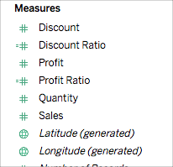

Use a calculated field in the view

Step 1: Build the view

1. From Dimensions, drag **Region**to the **Columns**shelf.
2. From Dimensions, drag **Category**to the **Rows**shelf.
3. On the **Rows**shelf, click the plus icon (**+**) on the **Category**field to drill-down to Subcategory.

The view updates to look like this:

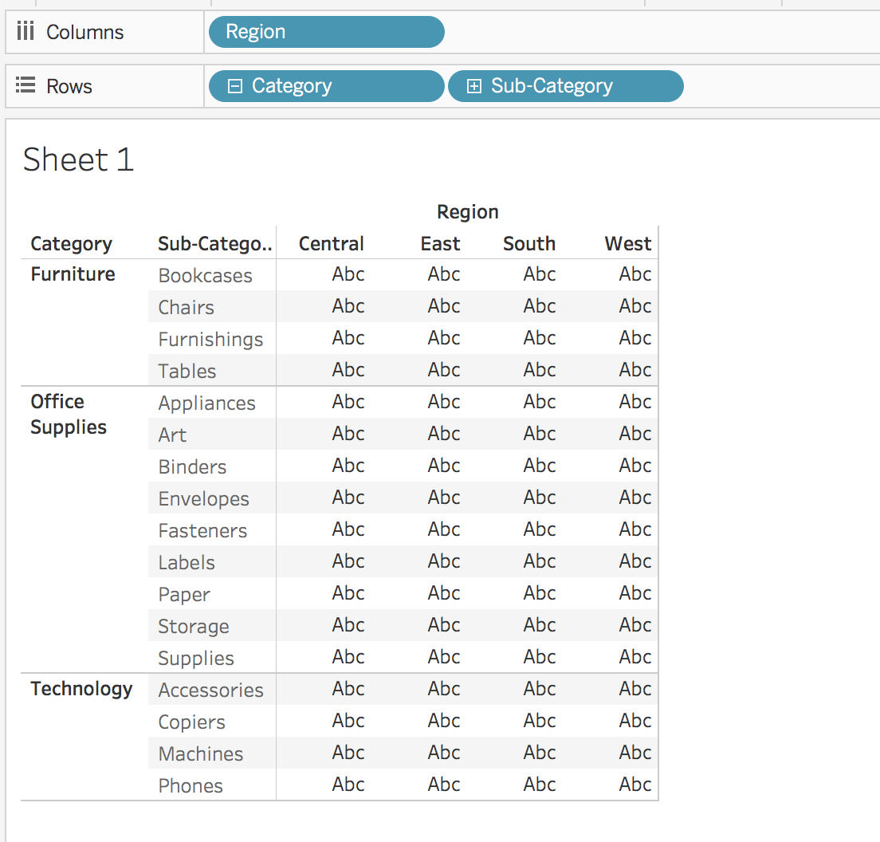

Step 2: Add the calculated field to the view

1. From Measures, drag **Discount Ratio** to **Color**on the Marks card.

The view updates to highlight table.

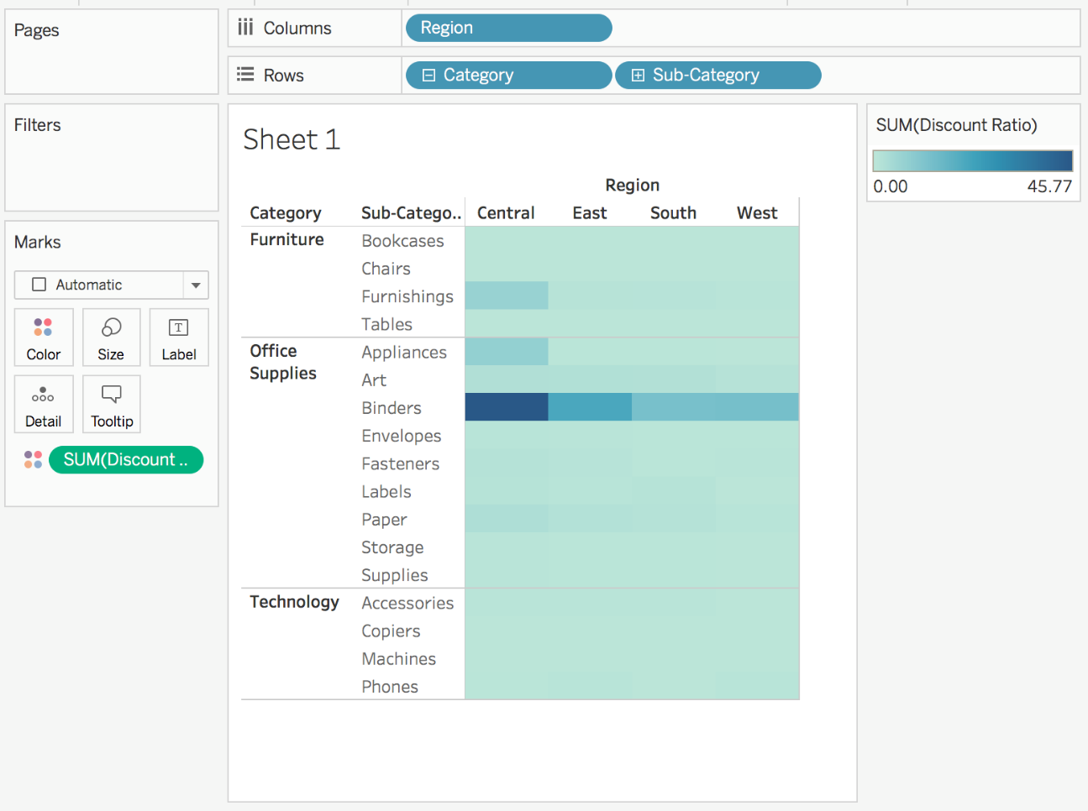

You can see that Binders are heavily discounted in the Central region. Notice that Discount Ratio is automatically aggregated as a sum.

1. On the Rows shelf, right-click **SUM(Discount Ratio)** and select **Measure (Sum)** > **Average**.

The view updates with the average of discount ratio shown.

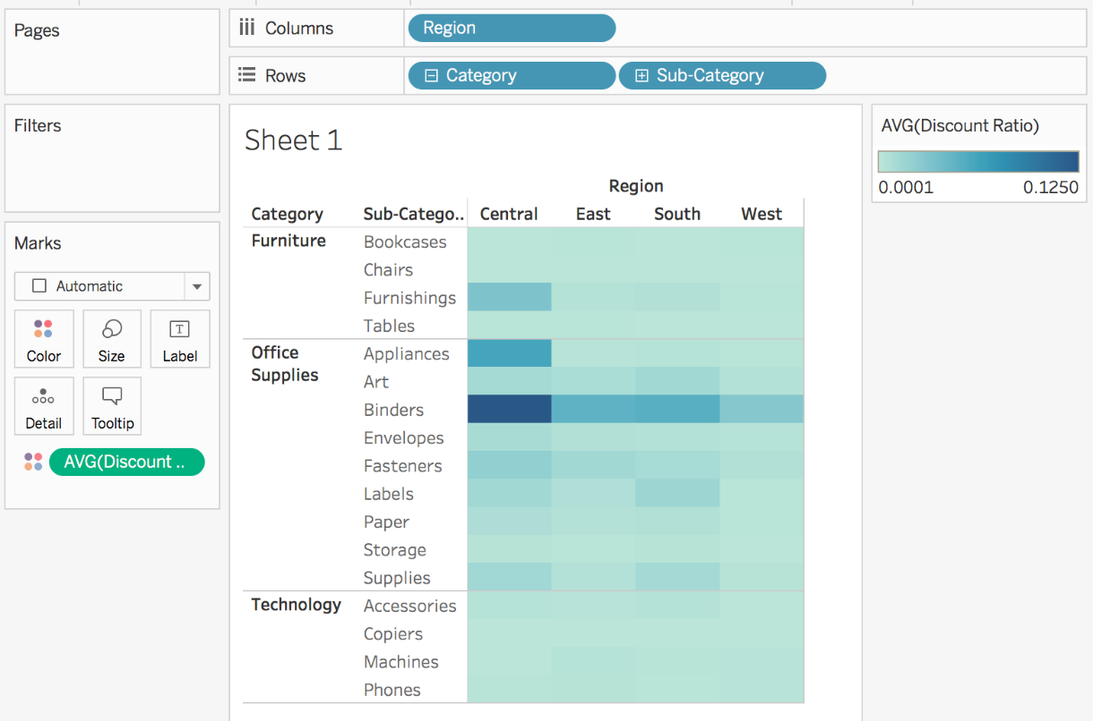

Edit a Calculated Field

If at any time you need to change a calculation, you can edit the calculated field and it will update across your entire workbook.

To edit a calculated field:

1. In the **Data** pane, right-click the calculated field and select **Edit**.
2. In the Calculation Editor that opens, you can do the following:
   * Edit the name of the calculated field.
   * Update the formula.

For this example, the formula is changed to return a discount ratio for orders over 2000 USD in sales:

IIF([Sales] > 2000, [Discount]/[Sales],0)

1. Click **OK**.

The view updates to reflect the changes automatically. You *do not* need to re-add the updated calculated field to the view.

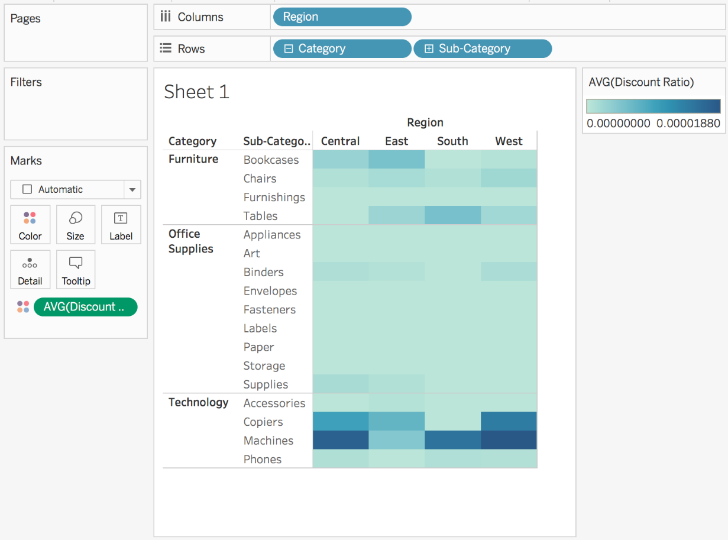

Bottom of Form